SoGross Amalgamated Competitor’s Product Analysis

First Author: Charlie Nitschelm

Second Author: Emily Perrone

Material Analysis Incorporated

09/16/2017

Dear SoGross Amalgamated,

Yesterday, we received a cross section of product that you sent to us. You requested a full elemental analysis of your competitor’s product. Included in this report is the requested analysis using our scanning electron microscope equipped with an energy dispersive spectroscopy.

It was a pleasure doing this analysis and look forward to continuing our professional relationship. Do not hesitate to contact us with any questions or further information needed from this report.

Regards,

The Material Analysis Incorporated Team

SoGross Amalgamated requested a full elemental analysis of your competitor’s product. The sample’s cross section was provided and prepared for us. Material Analysis Incorporated provides full elemental analysis using out scanning electron microscope (SEM) equipped with an energy dispersive spectroscopy (EDS). The following paragraphs summarize our observations in the form of annotated images and a brief description of our observations.

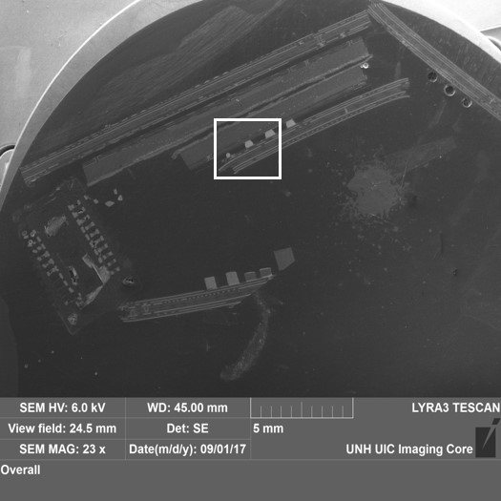

Figure - Low magnification of entire cross section of the specimen.

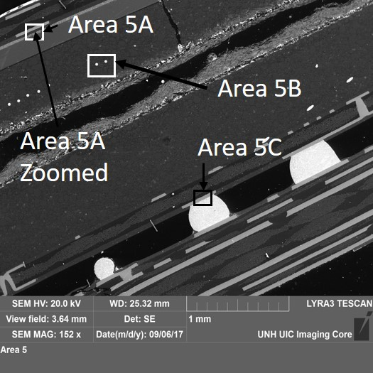 For our elemental analysis of your product, we used a Tescan Lyra 3 Field Emission SEM equipped with an EDS. The specimen was already prepared by SoGross Amalgamated as a cross section of the product. The data provided is semi-quantitative. We are unable to detect the presence of elements with concentrations below approximately 0.1% and cannot detect elements with atomic numbers below that for carbon.

Figure 1 and 2 are the low and high magnification of the specimen respectively. Figure 2 can be found in the white box drawn into Figure 1. Figure 2 is annotated with 4 areas that were analyzed for chemical analysis using our SEM equipped with an EDS. This report will begin with Area 5A which can be seen on the top left side of Figure 2. Area 5A Zoomed will be next, located within Area 5A. Area 5B is located to the right and below of Area 5A in Figure 2 and was the third region analyzed. Lastly, Area 5C was analyzed which is in the middle of Figure 2.

Figure - Zoomed in cross section of the specimen which can be found in figure 1 which is inside the white box.

To begin analysis, we used the SEM equipped with an EDS. The first point selection, which can be found in the top left of Figure 3, contains mostly copper with trace amounts of carbon. The first area selection, which can be found below and to the right of the first point selection, contained a large amount of carbon, oxygen and silicon with smaller amounts of sulfur and barium. Selected area 2, which is found below selected area 1, contains mostly silver and carbon with trace amounts of oxygen. Lastly, the second point selection, located at the bottom right of Figure 3, contained silicon.

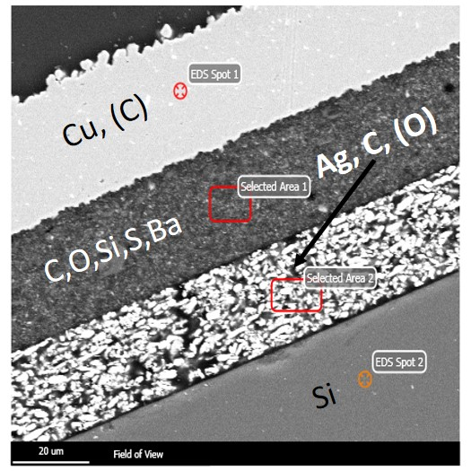

Figure - Zoomed in picture of Figure 2 located at Area 5A in Figure 2

The next area analyzed is inside Figure 3. Selected area 1 and 2 in Figure 3 are noticeably heterogenous. Figure 4 is inside these 2 heterogenous sections.

We used the SEM equipped with an EDS to analyze the material of 5 different spots defined in Figure 4. Starting with point 1, which is inside a lighter gray from its background, contained both silicon and oxygen. Point 2, an even lighter gray in relation to its background, contained mixed amounts of sulfur, barium, silicon, oxygen and carbon. Point 3 is located at the top right of Figure 4 which analyzed a dark spot in relation to a gray background, contained silicon, sulfur, barium and trace amounts of silver. The last two points were in the bottom half of Figure 4. Point 4 which is inside a very bright white located near the bottom right of Figure 4, contained silver. Point 5, a dark patch compared to the bright white, contained silver with a small amount of carbon.

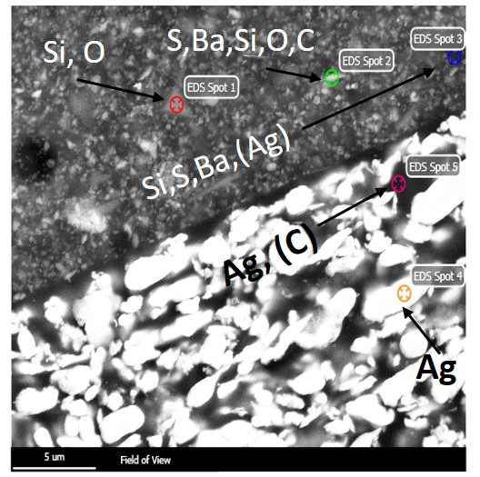

Figure - Zoomed in area of Figure 3 located in Area 5A.

We used the SEM equipped with an EDS to analyze the material of 4 different spots defined in Figure 5. Starting with point 1, which is inside a lighter gray from its background, contained both silicon and oxygen. Point 2, located near the top left of Figure 5, contained mixed amounts of aluminum with small amounts of silicon and oxygen. Point 3, near the middle of Figure 5 within a bright white dot compared to its dark surrounding background, contained gold with a small amount of carbon. The last point, located on the right side of Figure 5, analyzed the background darker gray material. Large amounts of silicon, aluminum and oxygen with small amounts of iron.

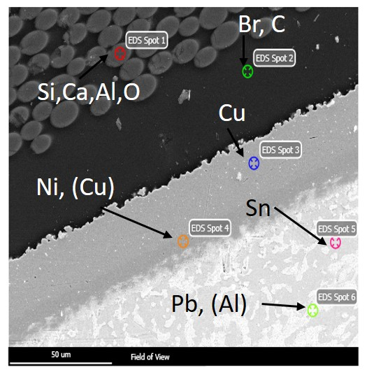

Figure - Zoomed in picture of Figure 2 located at Area 5C in Figure 2

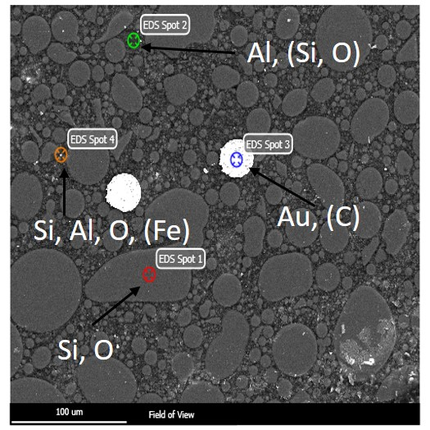

Figure - Zoomed in picture of Figure 2 located at Area 5B in Figure 2

We used the SEM equipped with an EDS to analyze the material of 6 different spots defined in Figure 6. Starting with point 1, which is inside a lighter gray from its background, contained mixed amounts of silicon, calcium, aluminum and oxygen. Point 2, the dark background in the top half of Figure 5, contained mixed amounts of bromine and carbon. Point 3 is located at near the middle of Figure 6 and contained only copper. Point 4 is in an imperfection in the same region as point 3 but contained mostly nickel and a small amount of copper. Points 5 and 6 are located at the bottom of Figure 6. Point 5 contains tin, which is the grayer background of that bottom section of Figure 6. Point 6, located in the white part in respect to its gray background, contains mostly lead with a small amount of aluminum.

Figure - Zoomed in picture of Figure 2 located at Area 5B in Figure 2